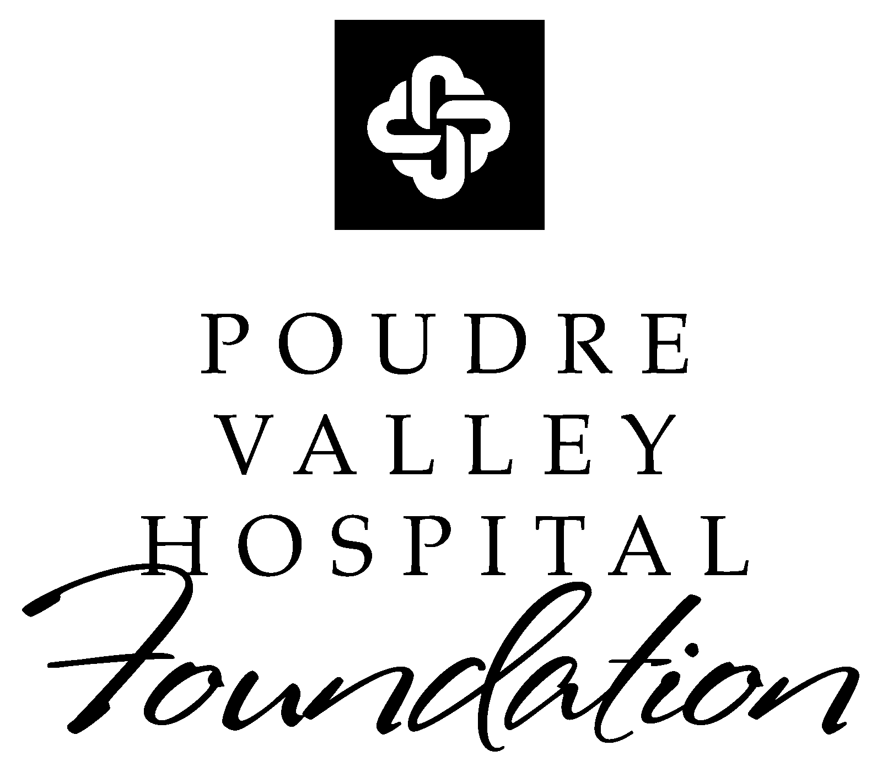

Yes, I would like to donate an auction item to the
30th Anniversary Poudre Valley Hospital Foundation Spring Benefit

Company Name

Contact Person

Title

Address

City State ZIP Code

Phone # Fax #

E-Mail

Item to donate _________________________________________________________________________

Retail value $

*A Representative of the PVH Foundation will contact you soon to arrange pickup of your auction item.*

Thank you
for your support of the
Poudre Valley Hospital Foundation
Spring Benefit!


Please send form to:

Mail:
Cheryl Glanz
Poudre Valley Hospital Foundation
2315 East Harmony Road, Suite 200
Fort Collins, CO 80528
Phone: 970.237.7406
Fax: 970.237.7490/E-mail: clg1@pvhs.org

